Beyond Environmental Arts Festival 2024
Youth Singers/Bands Application Guidelines

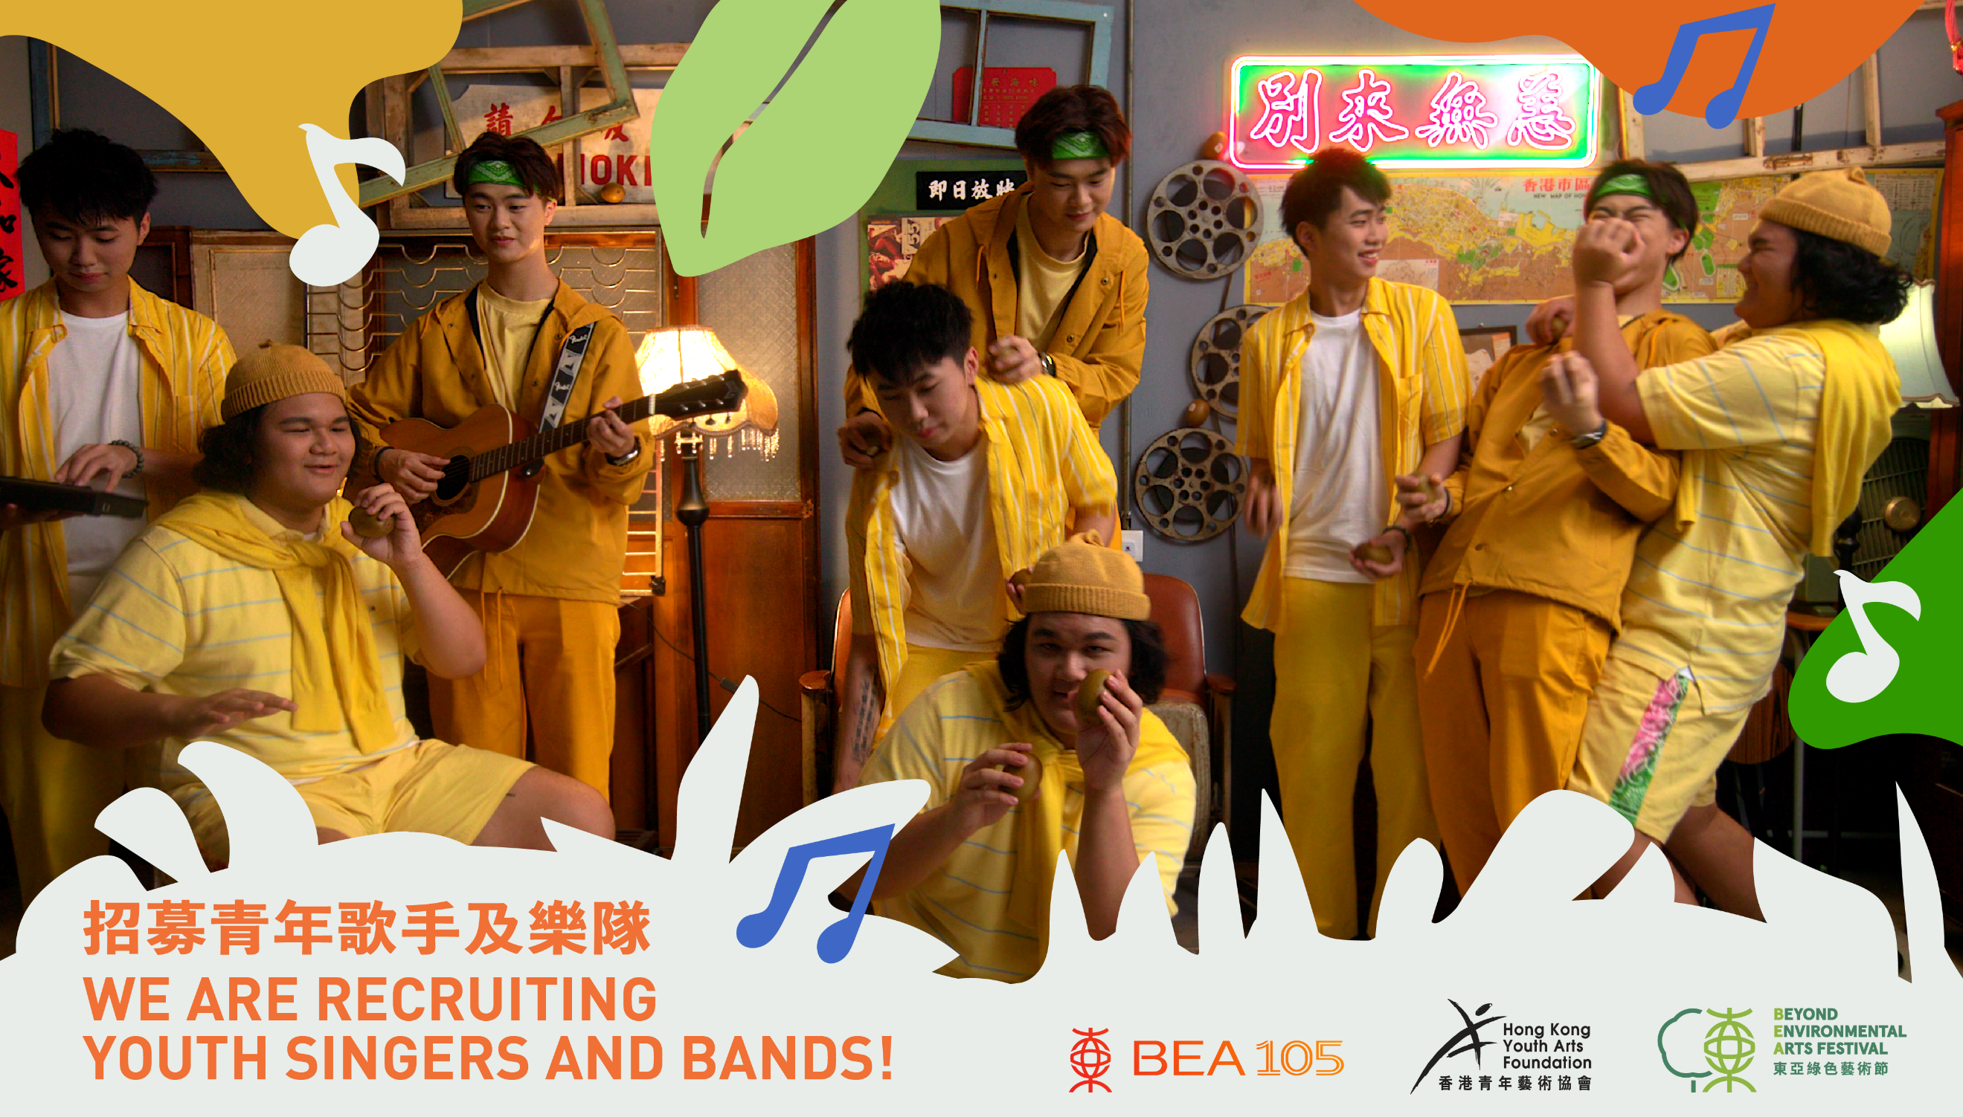

Timeline
9 May | Registration deadline
15 and 19 May (11am – 1pm) | Auditions (Singers/bands attend one session only)
Early June | Announcement of selected performers
14 June (6pm – 9pm) | General rehearsal (rehearse in sessions)
21 or 28 June (3pm – 8:30pm) | On-site run through and first performance (6pm – 8:30pm)
6 July (3pm – 8:30pm) | On-site run through and second performance (6pm – 8:30pm)

Audition and rehearsal venue:
- Music Studio, 6F, Youth Square, 238 Chai Wan Rd, Chai Wan
Performance venues:
- The Bank of East Asia Building, Central (21 or 28 June)
- BEA Tower, Kwun Tong (6 July)
HKYAF will provide selected performers with the following performance support:
- Free outdoor venue
- Technical assistance
- Assistance with publicity

Terms and Conditions of the performance
- Venue: The event takes place outdoors.
- Number of performers: Suitable for emerging solo singers and bands with up to 5 members.
- Participation: Selected singers/bands must be available to participate in the general rehearsal and both on-site run throughs and performances.
- Performance guidelines:
    - The duration of the performance should be AT LEAST 5 minutes but NO LONGER than 7 minutes.
    - The theme and content of the song/performance should engage audiences on the topic of climate change and encourage positive action.
    - The theme and content of the song/performance should be suitable for audiences of all ages and should not contain any vulgar language or adult topics.
Important Notes:
- Group representatives should check for emails from our organisation regarding full performance guidelines.
- Group representatives are responsible for sharing these guidelines with the other members of their group.
- Selected performers must be available to participate in the general rehearsal, and both on-site run throughs and performances:
  - 14 June (6pm – 9pm): General rehearsal (singers/groups attend once at designated time slots)
  - 21 or 28 June (3pm – 8:30pm): On-site run through and first performance (6pm – 8:30pm)
  - 6 July (3pm – 8:30pm): On-site run through and second performance (6pm – 8:30pm)
- Selected bands should provide details of all equipment and technical support required for the performance by 14 June (for our technical team’s reference).
- Please simplify technical and venue requirements as much as possible to ensure the smooth progress of the programme schedule.
- If singers/groups decide to cancel their performance after confirming participation, they must:
  - Immediately inform our staff.
  - Issue a press release to the media regarding the cancellation.
  - Handle all enquiries from the audience at the performance venues on the scheduled performance days.
- Hong Kong Youth Arts Foundation reserves the right to modify, use and publish the information and performance photos provided by you/your group for promotional purposes.
- The information you provide will be used for administrative and promotional purposes for the event.
- In the event of large-scale public events, severe weather conditions or other unforeseen circumstances, Hong Kong Youth Arts Foundation reserves the right to cancel the performance. If the performance is cancelled, our organisation will contact group representatives to provide further details.
Performers are responsible for the following:
- All performance expenses (excluding transportation costs).
- Our organisation may provide transportation subsidies for the transportation of musical instruments according to needs (limited to truck transportation only with valid receipts).
- Providing full and accurate information regarding their performance.
- Providing materials for the production of promotional publications for the event.
- Notifying Hong Kong Youth Arts Foundation immediately in case of any change in the contact person or if the contact person leaves Hong Kong.
- Working closely with Hong Kong Youth Arts Foundation and technical staff to ensure the smooth completion of the event.
- Helping to promote the event on social media.
- Punctually attending the general rehearsal, on-site run throughs and performances.

WAIVER OF LIABILITY AND DECLARATION:
In consideration of the foregoing, I, my group members, my group members’ heirs, my group members’ executors and administrators, do hereby waive and release any and all rights, claims and causes of action I and my group members have or may have against the Hong Kong Youth Arts Foundation, and all sponsors, promoters, supporters and all other contributors from any and all liability arising from illness, injury, death, loss and economic consequences I and my group members may suffer as a result of my entry in the “Beyond Environmental Arts Festival 2024” from any cause whatsoever, including negligence. I, and my group members, certify that we are physically fit to participate in this event. Further, we grant permission to the organiser, sponsors or their agents to use any photograph, video or any other record of the event for any lawful purpose.
Audition registrations will not be accepted after the deadline on 9 May 2024. Successful performers will contacted in early June to confirm participation and details regarding dates and times of rehearsals and performances.
Enquiries: mag@hkyaf.com / 2877 2656

